June. 1, 2023 Faith Builder Issue #6
A Faith Chapel Newsletter

Scripture of the Month

“The steadfast love of the Lord never ceases; his mercies never come to an end;
they are new every morning; great is your faithfulness.”
(Lamentations 3:22-23)

Sunday Service 10:00am

June 4th - Message by Pastor Clay Ford
June 11th - Message by Pastor Clay Ford
June 18th – Father’s Day - Message by Pastor Clay Ford
June 25th – Message by Pastor Brandon Harrison

FC Sunday Nights

June 4th – Prayer Night
June 11- The Chosen
June 18th – The Chosen
June 25th – The Chosen

Father’s Day

The nation’s first Father’s Day was celebrated on June 19, 1910, in the state of Washington. However, it was not until 1972—58 years after President Woodrow Wilson made Mother’s Day official—that the day honoring fathers became a nationwide holiday in the United States. Father’s Day 2023 occurs on Sunday, June 18.
Did you know? There are more than 70 million fathers in the United States.

Origins of Father’s Day
The campaign to celebrate the nation’s fathers did not meet with the same enthusiasm–perhaps because, as one florist explained, “fathers haven’t the same sentimental appeal that mothers have.” On July 5, 1908, a West Virginia church sponsored the nation’s first event explicitly in honor of fathers, a Sunday sermon in memory of the 362 men who had died in the previous

December’s explosions at the Fairmont Coal Company mines in Monongah, but it was a one-time commemoration and not an annual holiday. The next year, a Spokane, Washington, woman named Sonora Smart Dodd, one of six children raised by a widower, tried to establish an official
equivalent to Mother’s Day for male parents. She went to local churches, the YMCA, shopkeepers.
and government officials to drum up support for her idea, and she was successful: Washington State celebrated the nation’s first statewide Father’s Day on June 19, 1910. Slowly, the holiday spread. In 1916, President Wilson honored the day by using telegraph signals to unfurl a flag in Spokane when he pressed a button in Washington, D.C. In 1924, President Calvin Coolidge urged state governments to observe Father’s Day. Today, the day honoring fathers is celebrated in the United States on the third Sunday of June.
Faith Chapel: The Next Chapter
“Faith Chapel: Preparing for the Next Chapter” – Coming Soon!! Dr. Clayton Ford, who preached at our church on “Light of the World” on May 7th and May 21st, has recently been unanimously appointed by our Board of Directors to be our new Transitional Pastor, beginning in June. He will be preaching, teaching, and training us over the next two months (June and July) with a particular focus to help our church prepare for the very exciting new chapters of life and ministry that we believe God has planned for us! Pastor Clay has met with FC leaders and with Pastor Josiah about what’s planned, and there’s a deep sense of excitement and anticipation about what God is going to do among us during this time. We believe that this two-month focus is going to be extremely important as we come together, building a solid foundation that will carry us well into the future.
For that reason, we are asking and hoping for widespread participation of our church members and attenders in special teaching and training events (“Faith Chapel: The Next Chapter”) led by Pastor Clay. These events will be held every Wednesday night for the months of June and July from 6:30pm to 8:15pm, in the Activity Center. Our men’s Bible Studies and other Wednesday gatherings are suspending their regular meetings until August, so that everyone can participate in our two-month focus. (We are also asking any other Wednesday night groups to suspend their regular meetings and plan to participate.) Note: these gatherings are for everyone, including youth and young adults. However, it is especially important that all Faith Chapel ministry leaders and helpers, church staff, Board members, home group leaders etc. attend. You will be glad you did!! First meeting: 6:30pm Wednesday, June 7th – Spread the word!!

Clay and Cheryl Ford

New Employees

We are happy to introduce 4 new employees to our Faith Chapel family.

David Eberle has been hired to facilitate the many maintenance needs of the Faith Chapel campus. David has been attending Faith Chapel for several years and has been involved in the choir, homeless ministry, drama (he is our go to guy for playing Jesus), and several other areas.

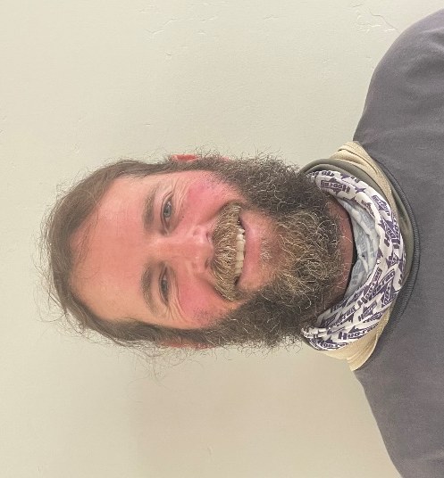
David Eberle

Tim Maxwell has been hired to assist faith Chapel in the areas of graphic design, visual arts, and marketing. Tim was born and raised right here in Spring Valley. He first gave his life to Jesus when he was about 12 years old and is so grateful for all that God has done for him. He met his wife, Maria, in church, and they were married in 2013. Since then, God has blessed the Maxwells with four beautiful children, Luke, Liana, Kaleb, and Kaden.

Tim Maxwell & Family

Emma Dresselhaus recently joined the Faith Chapel team as Social Media Coordinator. She has used her experience in photography and social media management to help run the SoCal Kidmin platforms, FC Youth, and others. She loves getting to use her creativity and photography for the Lord. Emma looks forward to further growing our community through the various Faith Chapel media platforms and hopes to capture the essence of our church.

Emma Dresselhaus

Kimberly Zendejas was hired on April 5th of this year as part of the facilities custodial staff. She has volunteered at “Meet the Need” for almost 3 years. Kimberly lives in Tijuana with her daughter Salma, speaks fluent Spanish, loves music and dancing, and having fun with Salma.

Kimberly Zendejas

Women’s Thursday Bible Class

A new women’s bible class hosted by Judy Lorenz begins this month. This study is based on the book, “The Magnificent Obsession” by Anne Graham Lotz. The book explores the embracing of the God-filled life. If you would like to be part of this study, that has a focus on the life of Abraham, meet each Thursday at 10:00am in the choir suite behind the Sanctuary.

Church Membership

Membership in the church is a very important part of belonging to Faith Chapel. Although there is no scriptural mandate for official church membership, there is certainly nothing to prohibit it. Church membership is a way of identifying oneself with a local body of believers and of making oneself accountable to proper spiritual leadership. Church membership is a statement of solidarity and like-mindedness (see Philippians 2:2). Church membership is also valuable for organizational purposes. It’s a good way of determining who is allowed to vote on important church decisions and who is eligible for official church positions. Church membership is not required of Christians. It is simply a way of saying, “I am a Christian, and I believe this church is a good church.” If you would like to become a member, please contact one of the church elders or inquire at the church administrative office.

Faith Chapel’s Newest Members

Derrick and Jennifer Cherry

Connect Classes

The purpose of a connect class is to provide a variety of scripture-based lessons to enhance the
spiritual journey of those who attend. Classes begin each Sunday at 8:30am and end at 9:30am. Below is the current list of classes available.

- “Sermon on the Mount” Presented by Dr. Timothy Dresselhaus in the Hospitality Suite.
- “The Epistles of Peter, John and Jude” - Growing and maturing in Christ as a community of believers. Presented by Eric Madril in LL4.
- “The Blessed Life: Unlocking the Rewards of Generous Living” Presented by Richard Dinnen in the administration office conference room.
- “The Book of Exodus.” Presented by Rose Necoechea in room C215.
- The book of Matthew is being presented by Marsha Streiker each Sunday from 12:00pm to 1:30pm in room C214.
- “Connect to Worship” - This is a time for everyone who loves worship to get together and grow in the gifts given to our church. Presented by LaMar and Yvette Key in the choir room.

Faith Chapel Karate Ministry

Sensei Charlie Moreno started this community outreach dojo in 1997. Shin Do Dojo is an American freestyle form of karate which originated from Japan. Shin Do Dojo means “School or Training Place, God’s Way in Japanese. It is open to the community and meets in the activity center on Tuesdays and Thursdays at 6:30pm. The dojo welcomes students to train from ages 5 to adult. American Freestyle Karate is about self-defense, discipline, and character development. It is taught at a faith-based dojo which emphasizes respect, obedience, and character traits that are biblically based which provide a good foundation for life. There is no Eastern mysticism or philosophy in the curriculum. The ministries core value verse is Matthew 7:14 “But small is the gate and narrow the road that leads to life, and only a few find it.” They practice the truth of I Timothy 4:8 “For physical training is of some value, but Godliness has value for all present life and the life to come.”
Sensei Moreno has attended Faith Chapel since 1985, is part of the security team and has served on the church board of directors. If you would like more information about the karate ministry or are interested in joining, you may contact Charlie Moreno through the church office at (619) 461-7451or by email at shindodojomom @ gmail.com.
Did You Notice It Before?

When the current campus of Faith Chapel was constructed in 1985 Pastor George Gregg requested that a cross be included on the outside of the main Sanctuary/Worship building. To fulfill his request a cross was built amid the louvered air vents above the FC Café. Did you know it was there?

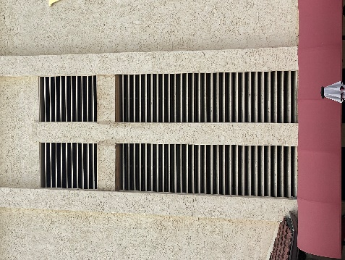

The Board of Directors recently voted to have the cross painted to better accentuate the cross on the building. Orlando Munoz volunteered to accomplish the painting. (Thank you, Orlando!)

Do you see it now?

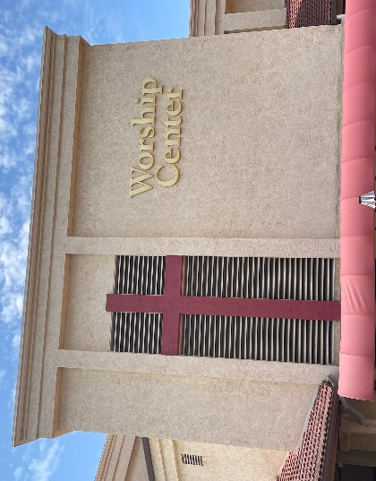

Volunteer Opportunities

There are many ways to serve and use your Spiritual Gifts here at Faith Chapel. Sunday nursery and children’s ministry, ushering, greeting, worship, production and media, special projects and hospitality are some of the ways you can get plugged in and use your talents and gifts.
to serve the body of Christ. If you would like to volunteer for any of these areas, contact the church office for more information.

Flash Back

Article from “The Faith Builder” June 1978

Missionettes Bake, Rock, and Sell Flowers in May
By Joyce Purvis

“The Missionettes were busy in May with money-making projects to earn their way to camp in July. Bake sales on Thursday nights after church brought in proceeds of over $41.00. The girls also sold orchid corsages for Mother's Day making a total of $69.00. The project that was enjoyed the most by all the girls was the 12-hour Rock-a-thon held at the One Way Inn on May 5th, Friday, 1978. At 9:00 p.m., 17 girls entered the doors armed with rocking chairs, pajamas, radios, stuffed animals, blankets, pajamas, and an alarm clock. Mark Townsend came to take pictures and stayed. He brought in his guitar and lead the girls in some choruses. Pat Hickok, Danielle Parks’ mother came back later in the evening and kept Sr. Sponsor Joyce Purvis company and helped her cheer the girls on. Out of the 17 girls there, 9 rocked the entire 12 hours with no breaks. Rhonda Jackson, Amy Dorsett, Danielle Parks, Phyllis Adkisson, Jody Bemus, Anna Manning, Maria Beck, Stephanie Banker, and Colleen Laney. (The Sr. Sponsor also made it the entire 12 hours!) The girls ended up the month of May by participating in the fashion show at the Mother's Day celebration banquet at the One Way Inn. Yes, the Missionettes were busy in May.”
VBS / Summer Fun

Due to the current transitional nature of Faith Chapel, there will not be a traditional vacation bible school this summer. However, there are three kids’ summer fun days planned. You don’t want to miss this! Be sure to invite your friends! Listed below are the scheduled themes and dates. Mark your calendar!

- June 30th – Family Movie Night - 6:30pm
- July 29th – Wacky Water Day – 1:00pm
- August 25th Glow Wild Night – 6:30pm

Classic Car Show

This year’s annual “Classic Car Show” will be held at Faith Chapel on Saturday, August 26th from 9:00am to 2:00pm. Proceeds benefit “Restoration Ranch.” Come out and support this great organization and enjoy the entertainment and awesome vehicles.

Faith Chapel

9400 Campo Rd. Spring Valley, CA 91977
(619) 461–7451

Follow us at:
FC App
faithchapelsd.com
YouTube
Instagram
Twitter
Facebook

